Getting Started with the

DU Mentor Program
Thank you for your interest in DU’s Mentor Program powered by the People Development team. We strive to create a culture of connection, competence, career development, community, and to provide development resources to meet the development goals of individuals where they are.

Experienced staff and faculty members will serve as mentors to staff and faculty interested in professional development, networking, learning and enhancing their leadership skills, and navigating career paths. Participation as either a mentor or mentee will provide you with the opportunity to build connections, support others, and better understand your role within your role, division, the University of Denver and beyond. This mentor program strives to ensure that a diversity of cultures, races and ethnicities, genders, ages, political and religious beliefs, physical and learning differences, sexual orientations and identities is thriving on our campus. Such diversity will enhance the learning opportunities for the mentors and mentees of our program.

Read on to learn more about the program guiding principles and ground rules.
Guiding Principles
- Mentoring is an enabling process that facilitates career development and professional skills exchange.
- The mentor and mentee are mutually committed to a beneficial mentoring relationship.
- Mentoring is based on an absolute commitment to trust and confidentiality between participants.
Ground Rules
Successful mentoring relationships negotiate and abide by ground rules. Some things to consider when determining ground rules for your mentoring relationship include:
- Recognizing a mentoring relationship is voluntary for both Mentor and Mentee
- Identify clear expectations for Mentors and Mentees
- Mentor and Mentee develop and adhere to a written Mentoring Agreement
- Identify Mentor availability and frequency of meetings
- Establish procedures for setting and conducting meetings
- Ensure that both Mentor and Mentee are actively involved
- Renegotiate the Mentoring Agreement as necessary
- Include a “no-fault” provision for ending the relationship
- Identify how and how frequently you will evaluate your relationship
- Recognize that a mentoring relationship is no guarantee of career advancement for the Mentor or the Mentee
- Identify confidential expectations

Program Outline
What is mentoring?
Mentoring is an opportunity for an experienced member of the University of Denver community (faculty or staff) to provide personal, professional, and career-related guidance to a staff or faculty member seeking such assistance. Mentoring programs have also been shown to support organizational DEI initiatives by highlighting professional development opportunities for historically excluded employees (Association for Talent Development 2020).

Starting in 2021, the Mentor Program has a new goal: to reach every New Employee and offer a mentor as part of their onboarding experience to intentionally build our community. We are excited for our mentors to be an integral of helping new employees feel welcome and providing them with the information and guidance that will benefit their career at DU.

Who is a mentor and what is their responsibility?
- Current DU employee – staff or faculty
- Provides support and helps the mentee by allowing them to come to their own decisions
- Review their situation through a process of reflection, questions, challenge, advice and feedback
- Commit to scheduled meeting times and clearly communicate if meetings need to be modified
Who is a mentee and what is their responsibility?
- Current DU employee – staff or faculty
- Wants to develop knowledge, skills, and/or awareness in a particular area
- The "driver" of the mentoring relationship
- Commit to scheduled meeting times and clearly communicate if meetings need to be modified
- Show up to each meeting prepared to discuss matters and be an active participant

How does the Mentor Program work?
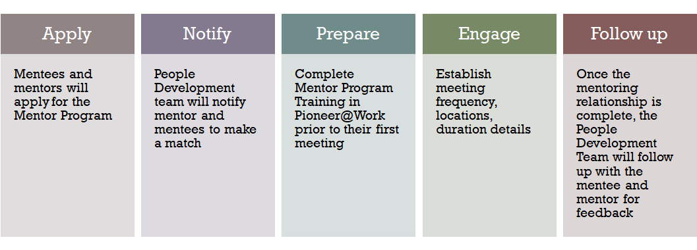
Will I receive any training on how to be a mentor or mentee?
Training will be assigned to both mentees and mentors in Pioneer@Work, DU’s talent management platform. The goal of this training is to prepare you with the resources and skills needed to successfully start and maintain the mentorship relationship. Both mentees and mentors are expected to complete the training prior to their first meeting.

How long does the mentorship relationship last?
We recommend that both parties meet a minimum of three (3) times over a span of three (3) (once/month). Both have the option of altering how often they meet as well as continuing.

Where can I find more information? Visit People Development’s Mentor Program
1st Meeting Guidelines
Discuss
To make your first meeting as productive as possible, consider discussing the following with your mentee/mentor:
- Work and professional background: Think about why you identify with someone’s work expertise and/or career. Visit each other’s LinkedIn profiles (as applicable) before the meeting to get an overview on your mentee/mentor does background.
- Values: What do you have in common?
- Past professional and personal successes and difficulties: What are several of your successes you are most proud of? What have been some difficulties and/or learning experiences?
- Interests: What are your top three interests professionally? Personally?
- Dreams and aspirations: What do you hope to accomplish in the next year? Next five years? How do you define success?
Commit
- What do next steps look like?
- Who will follow up with whom and how (i.e., phone call, email, calendar request, etc.)?
- How often will you meet and or how long?
- Who will initiate the meeting?
- What do we anticipate as challenges (distance, time, technology)? How do we commit to overcoming these challenges?

Getting to Know Each Other Resources
Explore
- How do I work best?
- What is my style?
- When are the best times to approach me?
- What are my core values that help me make decisions at work?
- What is the best way to communicate with me?
- What are some habits or situations I absolutely will not tolerate?
- How do I feel about giving feedback? Receiving feedback?
- What is the best way that others can help me to be successful?
Assessments
VIA Strengths Assessment (Free)
Based on positive psychology, learn more about your values and what you have in common by taking the VIA Strengths Assessment: https://www.viacharacter.org/survey/account/register.

CliftonStrengths Assessment ($19.99)
Completing the online talent assessment (formerly the Clifton StrengthsFinder) is your way to discover what you naturally do best, learn how to develop your greatest talents into strengths, and use your personalized results and reports to maximize your potential.
https://www.gallup.com/cliftonstrengths/en/253868/popular-cliftonstrengths-assessment-products.aspx

